Meet Rosalie Marcus: Speaker, Author, Business Coach
Rosalie@promobizcoach.com

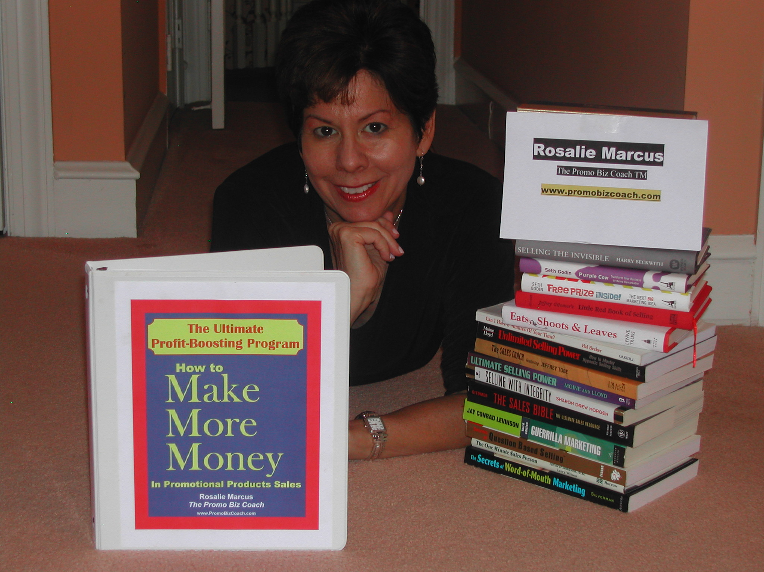
One of the questions I’m frequently asked is how I got started in the promotional products business, so here goes…
I was a teacher in an inner city school in Philadelphia, my hometown, when a teaching colleague introduced me to the promotional business. The teaching job was great preparation for promotional product sales. It taught me how to be creative, think on my feet and deal with multiple demands.

From the first order I sold I was hooked. I loved being in the business world, exploring new companies, finding out how they worked and presenting creative ideas.

I kept teaching part time for several years while I was building my promotional sales. I realized after some serious soul searching that if I was every going to make the business successful, I had to let the teaching job go and continue full speed ahead with Lasting Impressions, Promotional Products. Within three years my promotional business was cited as one of the 100 Fastest Growing Companies in my region and although at the time I was a divorced and a single parent, I was able to experience financial independence.

Today, I’m remarried to a great guy, Bob Winthrop, (also a speaker at the ASI! ® Show) my daughter’s grown and has her own successful career and I’ve taken my career to a new level by combining my teaching, coaching and business background to develop workshops and products to help promotional professionals work smarter, not harder!

I love to read, especially inspiring business books, which is why I decided to write one of my own, (but it’s a lot more than a book, it’s an entire success kit) How To Make More Money In Promotional Products Sales: The Ultimate Promotional Products Business Success Kit. I’m passionate about helping others to reach their full potential. Nothing makes me feel better than learning that my materials, coaching or workshops helped someone in our industry grow their sales.

For information about how I can help you grow your sales, increase your profits and work smarter, not harder go to contact me at Rosalie@promobizcoach.com / 215-572-6766. To get tips on how to grow your promotional sales in record time go to http://www.promobizcoach.com/blog

